**Name – Sarah Thomas**

**Reg. No: 23BSA10160**

**Subject: CSE3015 AWS Cloud Practitioner  
Slot: A11+A12+A13**

**Date: 11-07-2025**

**Assignment 1   
Create EC2 instance and host a static website.**

1. Login to the AWS Console

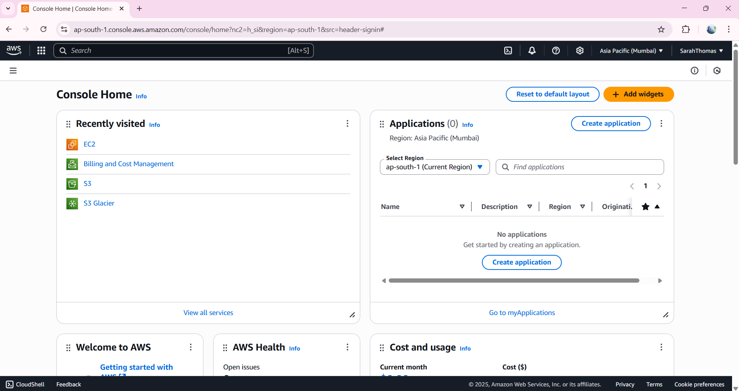

1. Navigate to Services -> Compute -> EC2 (virtual server)

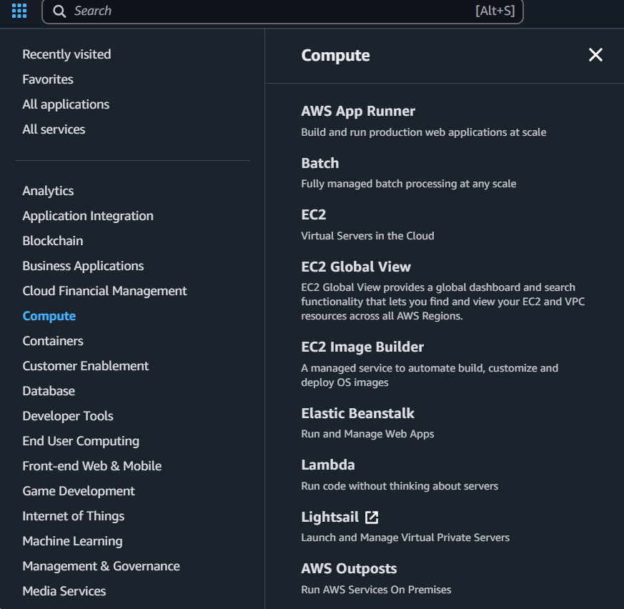

1. Click on Launch Instance.

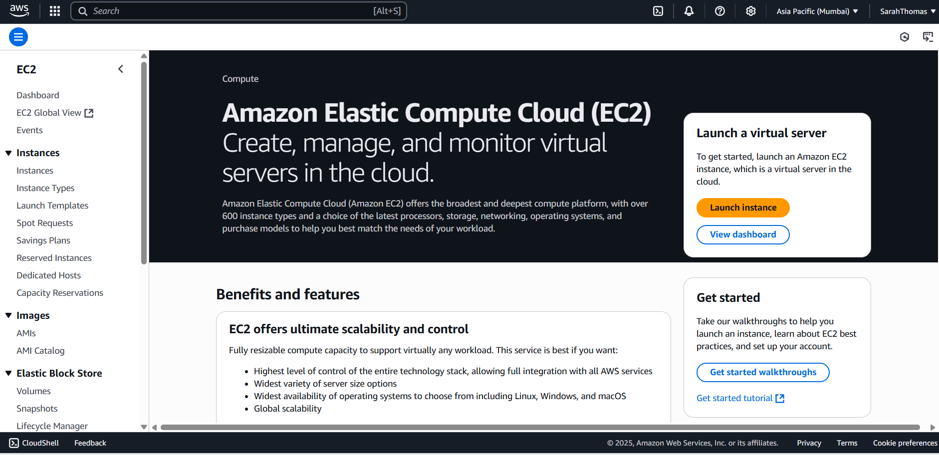

1. Give a suitable name to the instance

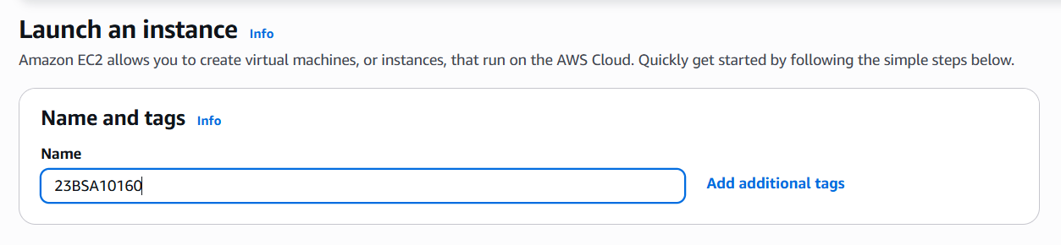

1. Select Appropriate Amazon Machine Image (AMI) for the server.

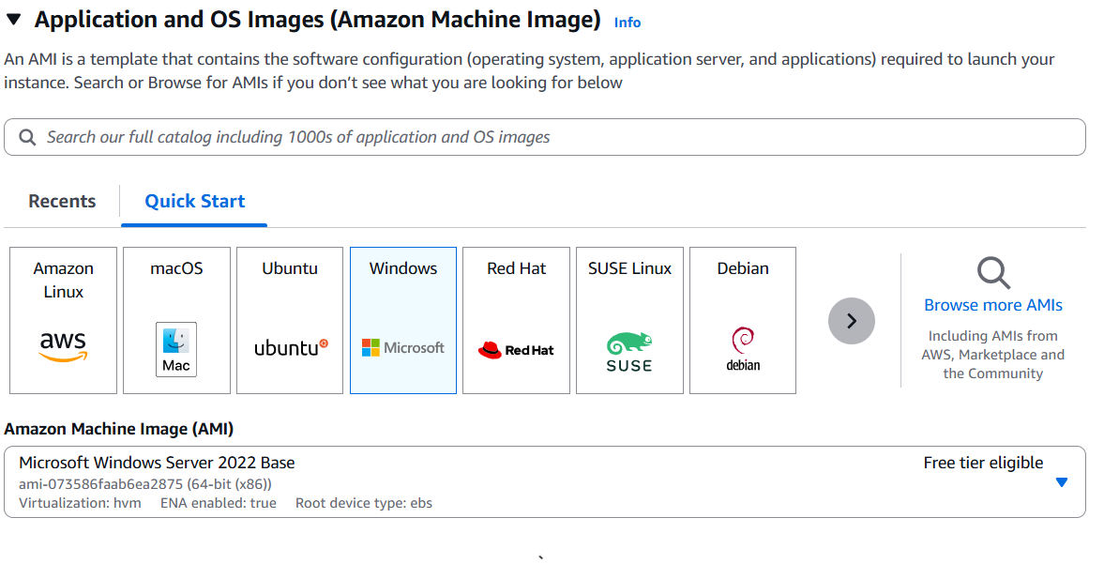

1. Select appropriate Instance type in here t2.micro

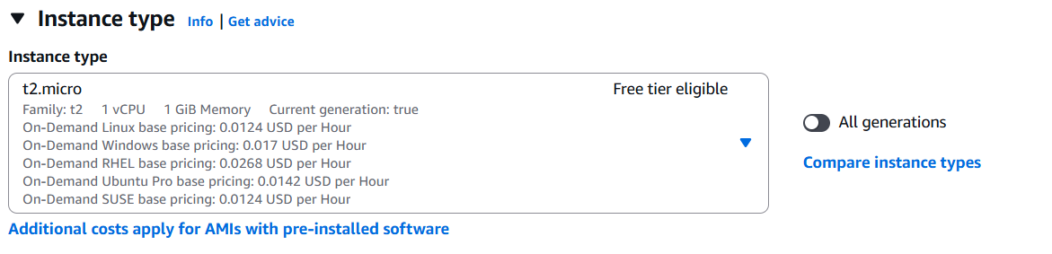

1. Create Key pair login.  
   Save the password file in .pem format.

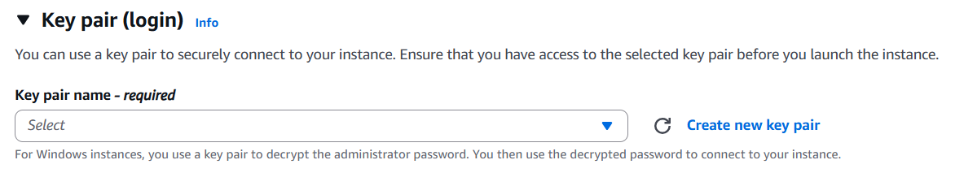

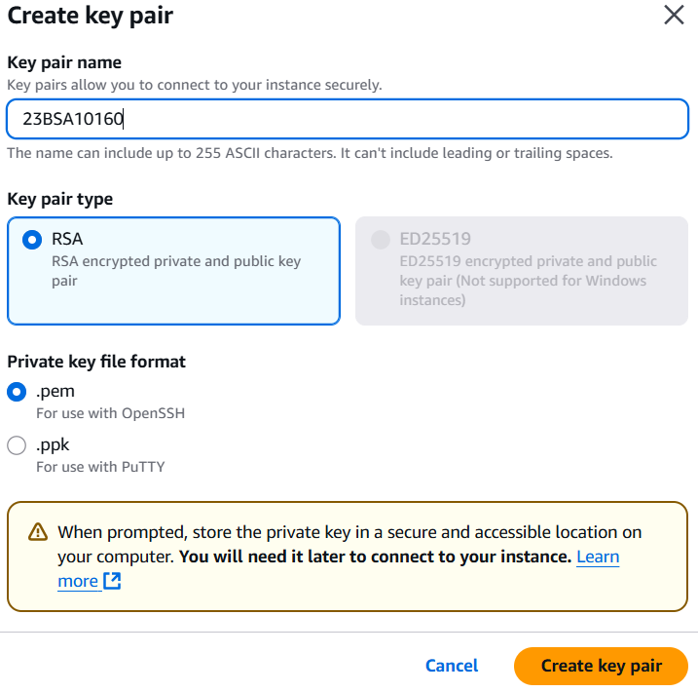

1. Under the Network Settings, allow HTTP and HTTPS traffic while keeping all the settings by default.

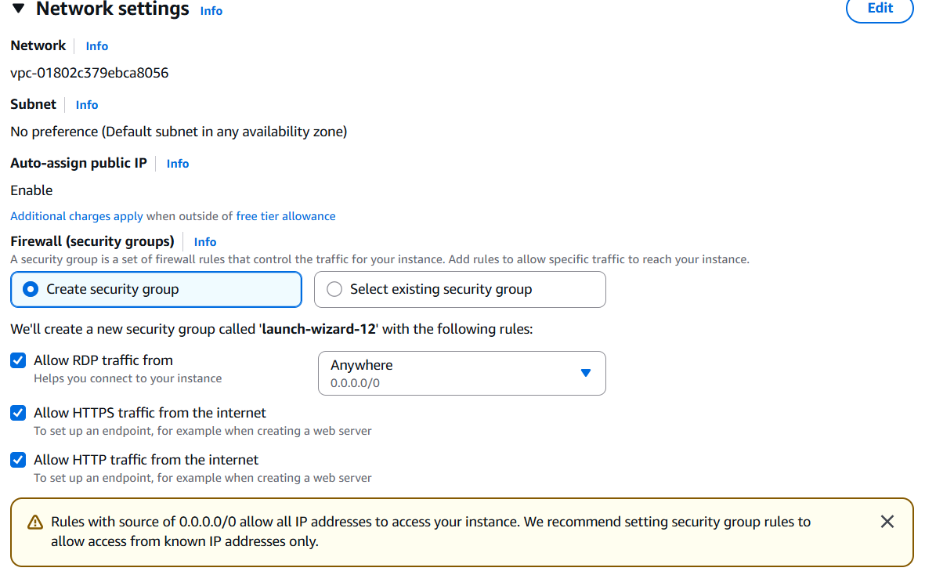

1. Under the Configure Storage Section, we can Select the Storage of our server.  
   By default, for free tier users a maximum of 30 GB is permitted to be used,

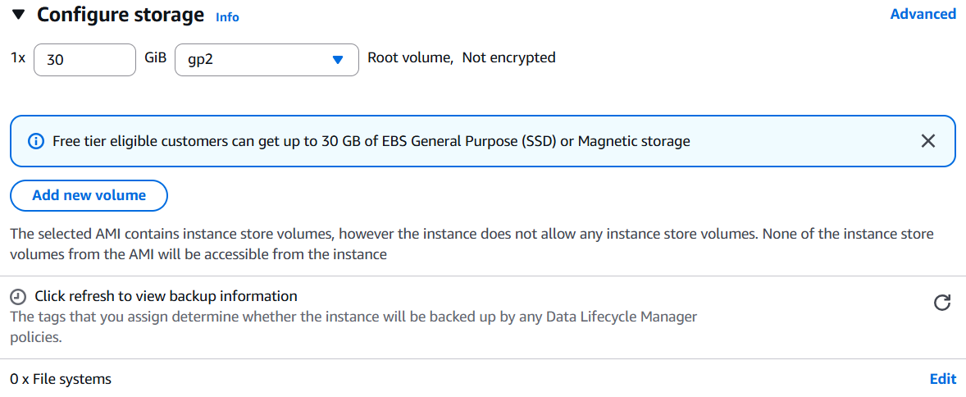

1. Next in the Summary Area, we can see the overall settings of our instance.

Once reviewed, click on Launch Instance.

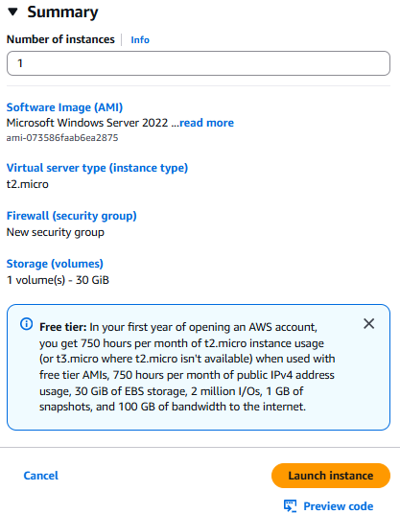

1. Once clicked, we are navigated to the Instances Page, wherein it shows the detail of our created instance.  
   We must wait until the instance passes a 2/2 check.

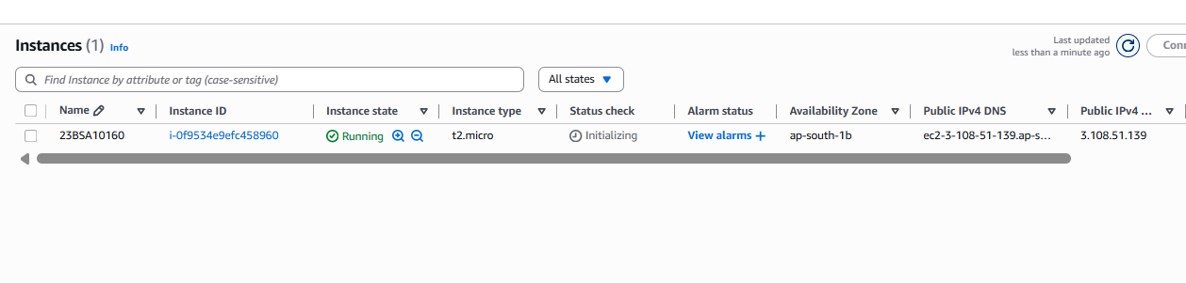

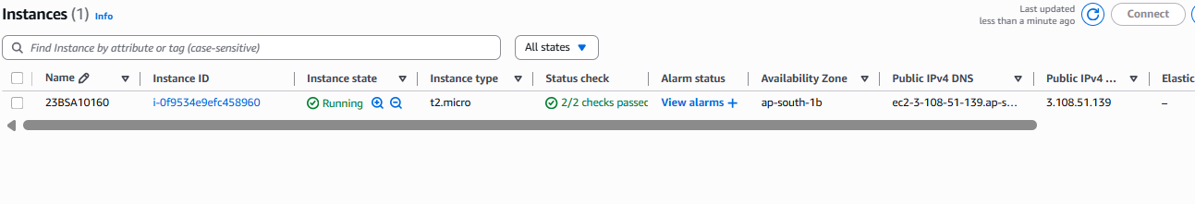

1. Now Select the Instance and Click on Connect.

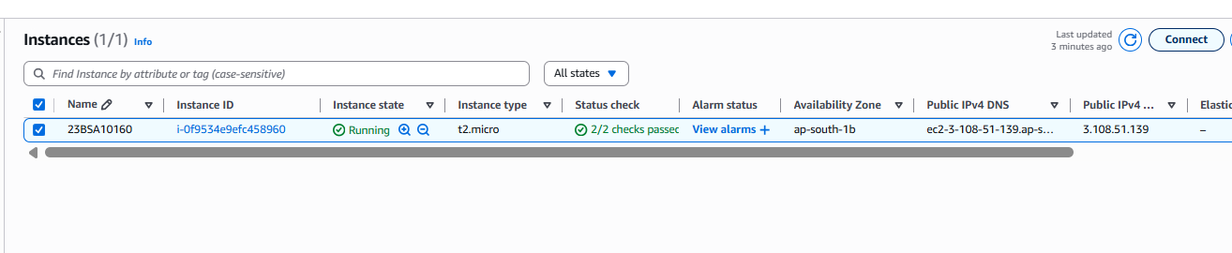

1. Click on RDP Client and Download Desktop File.

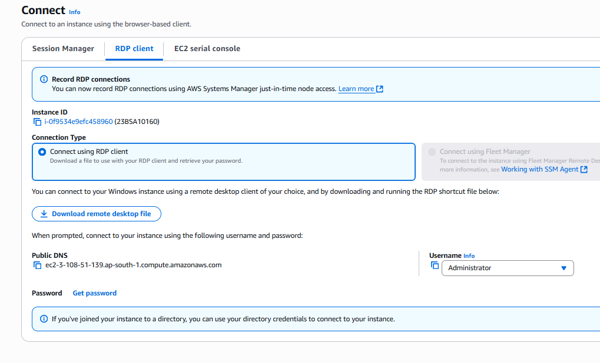

1. To get the password, upload the earlier password file(.pem), decrypt the file and copy the password.

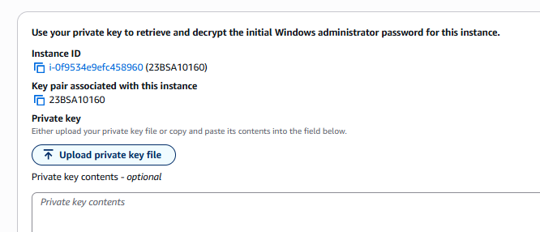

1. Open the Desktop file and paste the password.

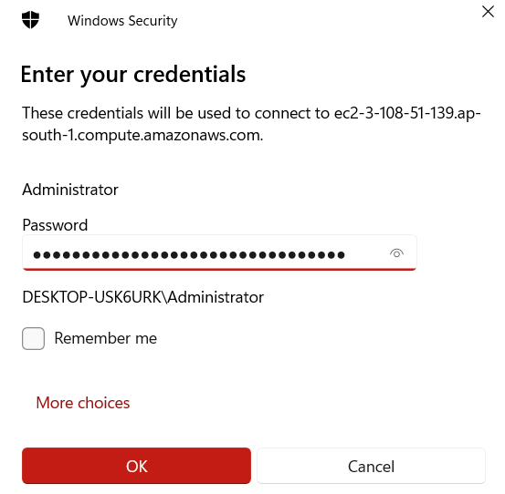

1. The Virtual server is now opened.

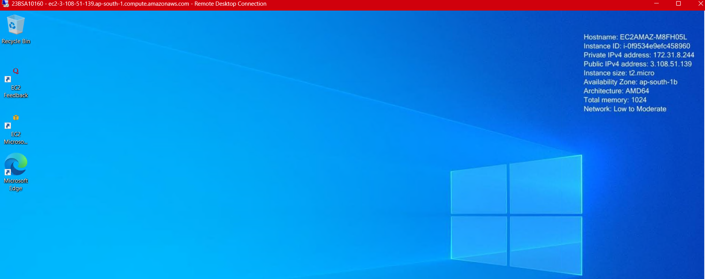

1. By this our virtual server is ready.
2. Now open Server Manager -> Add Roles and Features

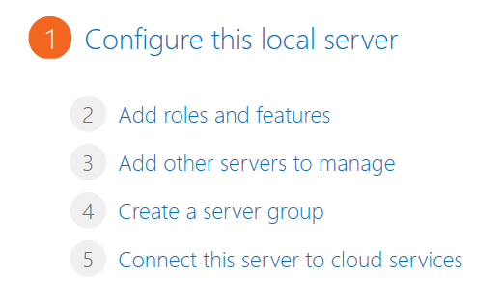

1. Add Web Server IIS and click Next.

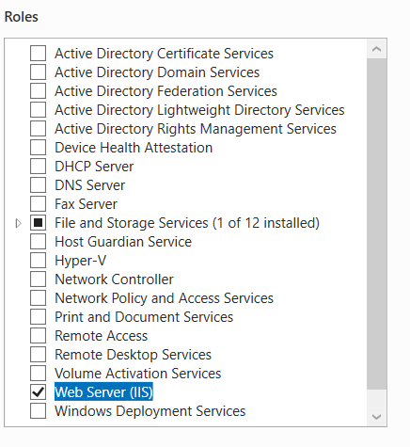

1. Now click on Install.

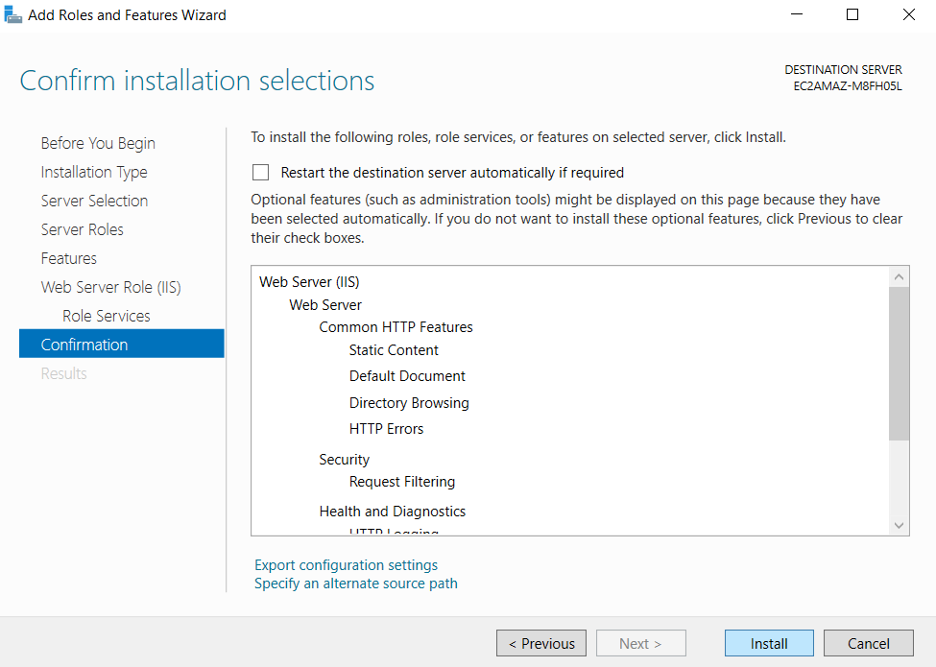

1. Once the installation is done, click on Close.

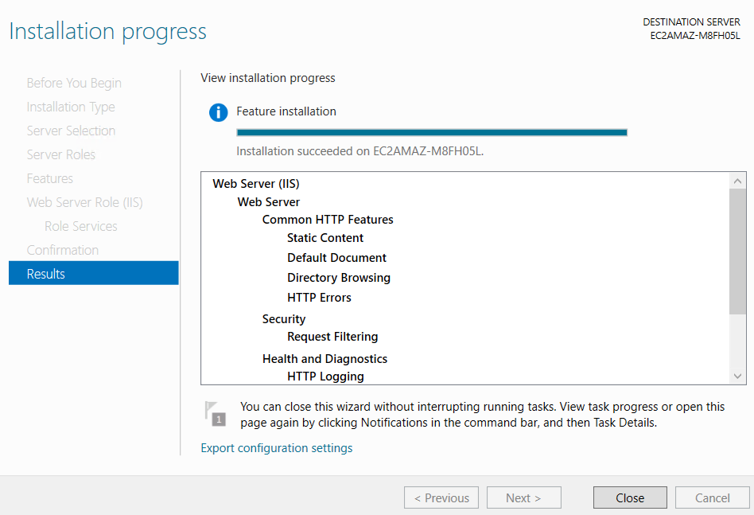

1. Then Navigate to This PC -> Local Disk C:

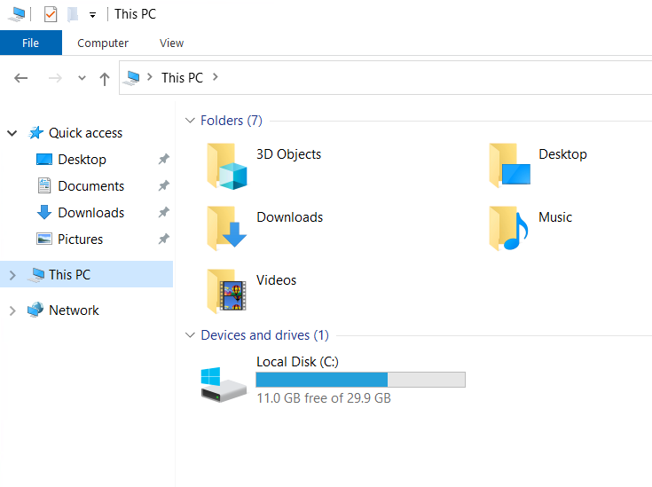

1. Navigate to inetpub and open the folder.

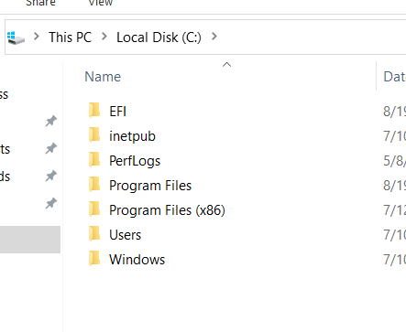

1. Now navigate and open wwwroot folder.

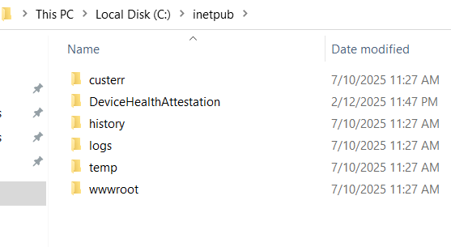

1. Now delete the two files present in wwwroot file.

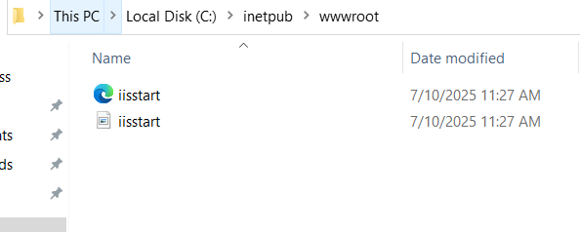

1. Open a Text File in the wwwroot folder.

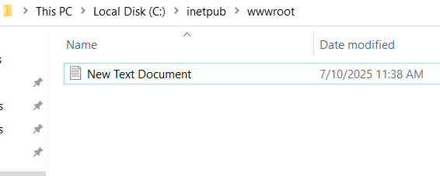

1. Write the content in the text file and Save As index.html file.

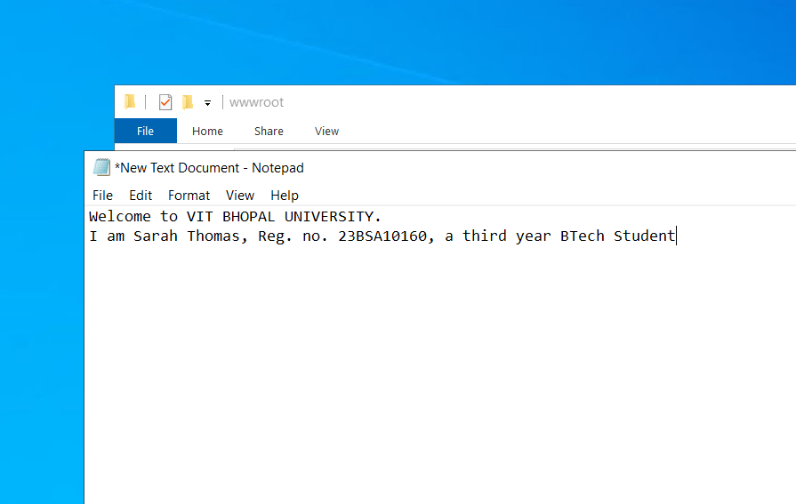

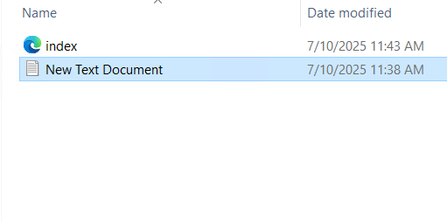

1. Now type the Public IP address on web browser say Chrome, Firefox, etc and view the content of the static website.

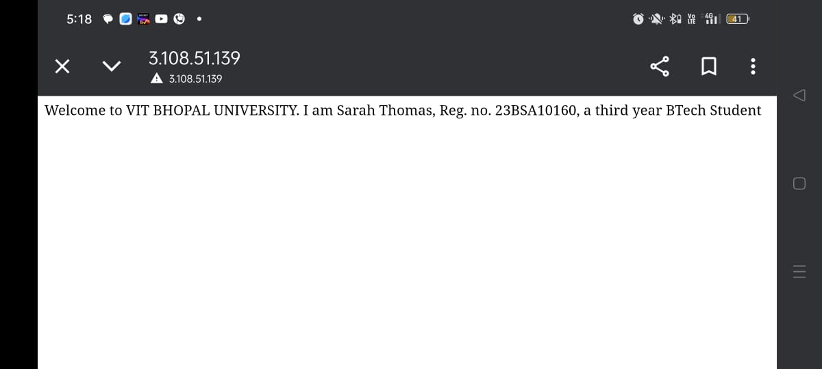

1. Like so we create an instance in EC2 and hosted a static website
2. Once the work is done, close the Remote Desktop file and terminate the instance.

